**Objective**

In this checkpoint, we have the following relational model:

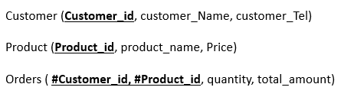

and their corresponding data types tables:

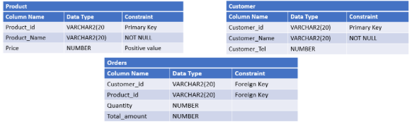

**Instructions**

1. You are asked to create the above given relational model using SQL language and based on the different mentioned constraints.
2. After creating tables, write SQL commands to:
   * Add a column Category (VARCHAR2(20)) to the PRODUCT table.
   * Add a column OrderDate (DATE)  to the ORDERS table which have SYSDATE as a default value.